MD2201: Data Science

Name of the student: Arya Pathak Roll No. 57

Div: C Batch: 3

Date of performance: 07/02/2024­

Experiment No.2

Title: Laboratory on Statistics
Aim: To find the probability for Binomial distribution and Normal distribution and verify the Normal approximation of Binomial distribution.

Software used: Programming language R.

Code Statement:
Write a single R code to answer the following questions.

Data Set: Travelled Abroad

- Find out the % of Indians in the sample who have travelled abroad using the data source.
- Treating this value as ‘p’, calculate the following probabilities –
  - What is the probability that in a randomly chosen sample of 10 persons, no one has travelled abroad?
  - What is the probability that in a randomly chosen sample of 10 persons, exactly one has travelled abroad?
  - What is the probability that in a randomly chosen sample of 10 persons, exactly two persons have travelled abroad?
  - What is the probability that in a randomly chosen sample of 10 persons, exactly three persons have travelled abroad?
  - What is the probability that in a randomly chosen sample of 10 persons, exactly four persons have travelled abroad?
  - What is the probability that in a randomly chosen sample of 10 persons, exactly five persons have travelled abroad.
  - What is the probability that in a randomly chosen sample of 10 persons, exactly six persons have travelled abroad?
  - What is the probability that in a randomly chosen sample of 10 persons, exactly seven persons have travelled abroad?
  - What is the probability that in a randomly chosen sample of 10 persons, exactly eight persons have travelled abroad?
  - What is the probability that in a randomly chosen sample of 10 persons, exactly nine persons have travelled abroad?
  - What is the probability that in a randomly chosen sample of 10 persons, all 10 persons have travelled abroad?
- Plot the probability values as a Table / Bar graph/plot and interpret plot.

- What is the probability that in the randomly chosen sample of 100 persons at least 59 have travelled abroad?
Hint: Expected to perform Normal approximation for the binary distribution.

Code: (Write code here)

library(dplyr)

df <- read.csv("../datasets/travelled abroad_csv.csv")

percent_indians_abroad <- mean(df$Travelledabroad == "Y") * 100

p <- percent_indians_abroad / 100

n <- 10

# a. Probability that in a randomly chosen sample of 10 persons, no one has traveled abroad
prob_no_one_abroad <- dbinom(0, size = n, prob = p)

# b. Probability that in a randomly chosen sample of 10 persons, exactly one has traveled abroad
prob_one_abroad <- dbinom(1, size = n, prob = p)

# c. Probability that in a randomly chosen sample of 10 persons, exactly two persons have traveled abroad
prob_two_abroad <- dbinom(2, size = n, prob = p)

# d. Probability that in a randomly chosen sample of 10 persons, exactly three persons have traveled abroad
prob_three_abroad <- dbinom(3, size = n, prob = p)

# e. Probability that in a randomly chosen sample of 10 persons, exactly four persons have traveled abroad
prob_four_abroad <- dbinom(4, size = n, prob = p)

# f. Probability that in a randomly chosen sample of 10 persons, exactly five persons have traveled abroad
prob_five_abroad <- dbinom(5, size = n, prob = p)

# g. Probability that in a randomly chosen sample of 10 persons, exactly six persons have traveled abroad
prob_six_abroad <- dbinom(6, size = n, prob = p)

# h. Probability that in a randomly chosen sample of 10 persons, exactly seven persons have traveled abroad
prob_seven_abroad <- dbinom(7, size = n, prob = p)

# i. Probability that in a randomly chosen sample of 10 persons, exactly eight persons have traveled abroad
prob_eight_abroad <- dbinom(8, size = n, prob = p)

# j. Probability that in a randomly chosen sample of 10 persons, exactly nine persons have traveled abroad
prob_nine_abroad <- dbinom(9, size = n, prob = p)

# k. Probability that in a randomly chosen sample of 10 persons, all 10 persons have traveled abroad
prob_all_ten_abroad <- dbinom(10, size = n, prob = p)

cat("Percentage of Indians who have traveled abroad:", percent_indians_abroad, "%\n")
cat("Probability of no one has traveled abroad:", prob_no_one_abroad, "\n")
cat("Probability of exactly one person has traveled abroad:", prob_one_abroad, "\n")
cat("Probability of exactly two persons have traveled abroad:", prob_two_abroad, "\n")
cat("Probability of exactly three persons have traveled abroad:", prob_three_abroad, "\n")
cat("Probability of exactly four persons have traveled abroad:", prob_four_abroad, "\n")
cat("Probability of exactly five persons have traveled abroad:", prob_five_abroad, "\n")
cat("Probability of exactly six persons have traveled abroad:", prob_six_abroad, "\n")
cat("Probability of exactly seven persons have traveled abroad:", prob_seven_abroad, "\n")
cat("Probability of exactly eight persons have traveled abroad:", prob_eight_abroad, "\n")
cat("Probability of exactly nine persons have traveled abroad:", prob_nine_abroad, "\n")
cat("Probability of all ten persons have traveled abroad:", prob_all_ten_abroad, "\n")

probabilities <- data.frame(
Scenario = 1:10,
Probability = c(prob_one_abroad, prob_two_abroad, prob_three_abroad,
prob_four_abroad, prob_five_abroad, prob_six_abroad, prob_seven_abroad,
prob_eight_abroad, prob_nine_abroad, prob_all_ten_abroad)
)

#
bar_plot <- ggplot (probabilities, aes(x = Scenario, y = Probability)) +
geom_bar(stat = "identity", color = "black", fill = "skyblue") +
labs(title = "Probability of Number of Persons Who Have Traveled Abroad",
x = "Number of Persons Who Have Traveled Abroad",
y = "Probability") +
theme_minimal() +
theme(plot.title = element_text(hjust = 0.5))

print(bar_plot)

n <- 100
p <- percent_indians_abroad / 100

mu <- n * p
sigma <- sqrt(n * p * (1 - p))

cat("Mean: ",mu, "\n")

cat("Std Dev: ",sigma, "\n")

prob_at_least_59_abroad <- 1 - pnorm(59, mean = mu, sd = sigma, lower.tail = TRUE)

cat("Probability that at least 59 persons have traveled abroad in a sample of 100 (using normal approximation):", prob_at_least_59_abroad, "\n")

library(ggplot2)

n <- 100
p <- percent_indians_abroad / 100

prob_at_1east_59_abroad <- sum(dbinom(59:100, 100, p))

cat("Probability that at least 59 persons have traveled abroad in a sample of 100:", prob_at_1east_59_abroad, "\n")

Results: Display the output obtained on R console for all the cases. Also add the plots which you obtained. Give proper title to the plots as per the condition.
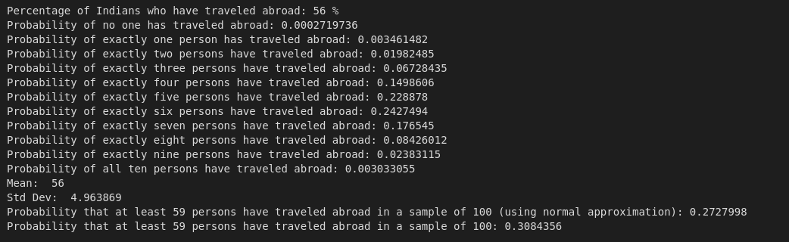

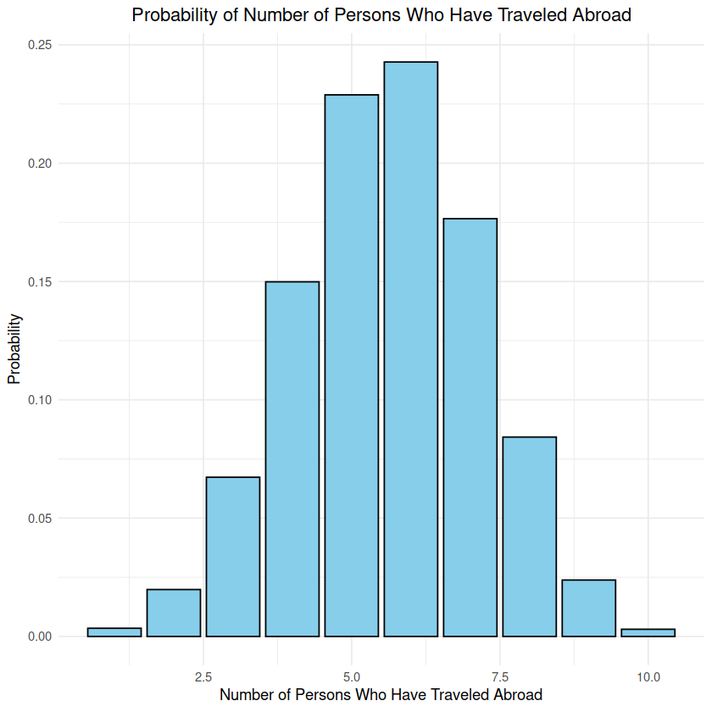

Conclusion: (Write the conclusion in your words)

This experiment in R explored the probabilities associated with binomial distributions and the normal approximation of a binomial distribution. We analyzed data on travel habits, specifically focusing on the percentage of Indians in the sample who have traveled abroad. The code first calculated the probability of finding a specific number of well-traveled individuals within a random sample of 10 people. The results were visualized with a bar graph, revealing that finding 5 or 6 people who have traveled abroad is the most probable scenario.
Secondly, the code explored the normal approximation of the binomial distribution. Here, we investigated the probability of finding at least 59 people who have traveled abroad in a sample of 100. This analysis highlights the usefulness of normal distributions in approximating binomial distributions when the sample size is sufficiently large.

